Commentary >> Third Party Commentary >> Symposium Papers (CPA Canada Commodity Tax) >> 2001 (Ottawa, September 24-26) >> 5. Critical Customs Issues — 2001: CCRA Programs You Need To Be Aware Of

CRITICAL CUSTOMS ISSUES — 2001: CCRA PROGRAMS YOU NEED TO BE AWARE OF
By: John Besnec, VP Int'l Trade & Gov't Relations
Canadian Association of Importer & Exporters

Executive Summary
The Canada Customs and Revenue Agency (CCRA) were confronted with numerous challenges when it came to managing international trade and tourism across Canada's borders. The tragic events of September 11, 2001 have since placed increased pressures upon the CCRA to not only increase the levels of security at our borders but also to more effectively manage the tremendous backlogs and commercial and passenger traffic at the Canada/U.S. border. This document will concentrate primarily upon the highlights that will be given in my presentation regarding the plans and directions that have been developed by the CCRA under the Customs Blueprint Action Plan.
With decreasing resources, both in funding and in manpower, the CCRA determined that risk management supported by technology was the only viable means to manage effectively the ever-increasing volume of goods and people crossing Canada's borders. Minister Dhaliwal subsequently launched the CCRA "Blueprint" on October 21, 1998. The objective was to create an action plan to guide program investment for the first five years of the new millennium. Following the launch of the "Blueprint" Minister Cauchon launched the "Customs Action Plan" on April 7, 2000. Within this plan the following initiatives were identified: stopping illegal activity; protecting Canadian citizens from threats to their health, safety and security; investment in innovative solutions that would help companies be competitive and make our communities safer. The key program initiatives will all be based upon the principles of risk management. They include Travellers Re-engineering, Commercial Re-engineering and Infrastructure Reengineering.
Travellers Re-engineering will consist of expedited passenger processing systems, advanced passenger information and CANPASS expansion and harmonization with the U.S. Advanced biometrics technology will be adopted where passengers at airports will be subjected to retinal and handprint scans. Commercial Reengineering will include programs that are already underway at certain stages such as Customs Self Assessment (CSA) and Carrier Re-engineering. The focus will be on a set of strategic design features for the report, release and accounting of goods. Under CSA there will be a migration from requiring transactional release data to a simple identification process for known, low risk shipments for pre-approved importers. Under Carrier Re-engineering there will be a move from accepting minimal data to the requirement for pre-arrival data to permit the targetting of unknown or high-risk shipments for contraband and for health and safety reasons at the first point of arrival. Traders will be urged to move from a paper-based environment to an electronic one.
To support these new initiatives the Administrative Monetary Penalty System (AMPS) will be introduced. This new sanctions regime will be designed to support the entire Customs program and to encourage, secure and sustain compliance. AMPS will be a graduated penalty system where penalties will range from initial "warnings" in a very limited number of cases, to a maximum penalty amount of $25,000 per infraction. According to the CCRA, AMPS is designed to provide an effective set of consequences for non-compliant behaviour. AMPS will also improve compliance management for the CCRA through the implementation of an automated mechanism to assess all penalties, to retrieve client compliance performance data and to monitor penalty effectiveness.
The Infrastructure Re-engineering will consist of the Integrated Customs System (ICS), which will provide the platform on which all the "Blueprint" initiatives will be built. It will consist of a component-based architecture where the business function that is developed will be reused wherever it will be needed.
Customs audit priorities and programs will also be affected. The Periodic Verification Initiative (PVI) has now evolved into new programs such as Compliance Assessment Review (CAR) and the New Verification Process (NVP). There will a renewed focus on specific industry sectors that have been deemed as national priorities for 2001 to 2002. The affected industry sectors, which include steel, textiles, apparel, footwear and those dealing with tariff rate quotas will be subject to added scrutiny and audit.
The focus and the timelines for some of the initiatives under the "Customs Action Plan" may change because of the need for greater security at our borders. The direction that the CCRA will be taking will, however, not significantly alter. For Canadian companies to be able to import and export goods in this 21st century they will have to be compliant. Anything less then being compliant will have serious financial impact. To be compliant you will need to be informed and you will need to be involved.
John Bescec
Vice President, International Trade and Government Relations
Canadian Association of Importers and Exporters

Challenges For The CCRA
• Trade, Tourism, Competitiveness and Protection
• Streamlining the movement of low risk travellers and trade
• Risk management supported by technology
• Understanding how business operates and getting trade buy-in

From Blueprint To Action Plan
• Blueprint launch
• Customs Action Plan
• Support for Throne Speech Priorities
• Key Initiatives
• Travellers Re-engineering
• Commercial Re-engineering
• Infrastructure Re-engineering

Risk Management
• Focus on all risk  • Interviewing travellers  • Minimal transactional data  • Inland release  • Transactional verification  • Domestic requirements  • Seizures | è | • High & unknown risk  • Pre-registering travellers  • Targetting data  • Frontier release  • Periodic verification  • International requirements  • Graduated penalties

Commercial Re-engineering
• Focus on set of strategic design features for the report, release & accounting of goods
• From transactional release data to simple identification process
• From acceptance of minimal data to pre-arrival data
• Paper based to electronic
• Transactional accounting to client's own business records and periodic reviews
• Inland release to frontier release
• Interviewing drivers to pre-registration system
• Domestic data requirements to standard int'l data
• Seizure approach to graduated penalties

Customs Self Assessment
• No pre-arrival transactional data — only identification of key players at primary inspection line (PIL)
• Trade data and revenue reports filed from commercial business systems
• Self assessed revenue payments and adjustments
• Account management approach

CSA - Who Is Eligible?
• Importers and carriers who are:
• Known to customs
• Low risk (without contraband or major commercial infractions)
• Willing to enter into a performance agreement with CCRA
• Supportive of CCRA's right to perform audits
• Approved drivers

CSA - Application and Approval
• Part I - risk assessment
• Part II - books and records, business systems
• Part III - performance agreement

CSA - Accounting
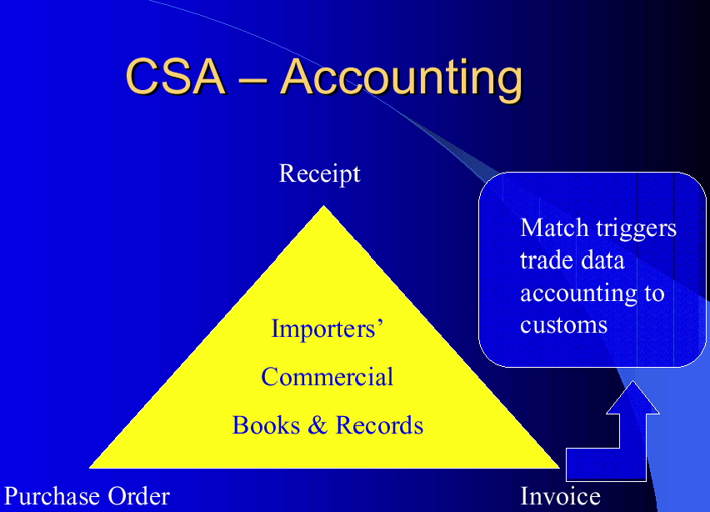
• Accounting timeframes expand
• Two options:
— Option one - goods received in month one must be accounted for by the 18th of month two
— Option two - goods received between the 19th of month one and the 18th of month two must be accounted for by the last business day of month two

CSA - Payment
• Payment timeframe
• Goods received between the 19th of one month and the 18th of the next month are payable on the last business day of the second month
• Interim payment
• Goods received between the 1st and the 18th of one month must be fully accounted and paid by the end of that month or an interim payment will be required
• Payment process involves
• Transmission or presentation of revenue information on a revenue summary form (RSF)
• Breakouts by tax and duty types
• Payment of the total due through a financial institution

Carrier Re-engineering
• Getting the right information at the right time on a transactional basis
• Increased reporting data required electronically on a pre-arrival basis
• Decisions for examination made at the point of arrival
• Driver registration
• Expedited processing for low risk shipmen

Administrative Monetary Penalty System
• Provides for the imposition of graduated monetary penalties
• Effective set of consequences for non-compliant behaviour
• Internal administrative correction procedure
• To improve compliance management through an automated mechanism

Penalties
• Example - failure to report a commercial importation valued at $1,600 or greater
• 1st infraction - $1,000 or 5% of value for duty whichever is greater
• 2nd infraction - $2,000 or 10% of value for duty whichever is greater
• 3rd infraction - $3,000 or 20% of the value for duty whichever is greater

AMPS Cont'd
• AMPS cannot be applied retroactively; However, previous rulings, court decisions, etc. Are applicable in establishing whether the importer has "reason to believe"
• Persons subject to AMPS may abandon goods, but unlike seizure, they still are subject to AMPS penalty

Integrated Customs System
• ICS provides the platform on which all the Blueprint initiatives will be built
• Component based architecture
• Single technological platform
• Simple to use
• Simpler, quicker and less costly
• Consistency

Audit Programs
• Changing audit priorities
• Periodic verification initiative (PVI)
• Focus on specific industry sectors
• New audit programs
• Compliance assessment review (CAR)
• New verification process (NVP)
• Sustained compliance

Affected Industry Sectors
• National priorities for 2001 - 2002
• Steel
• Textiles
• Apparel
• Footwear
• Tariff rate quotas

CAR
• Compliance assessment review has a commodity or product focus
• Involves in-depth client profiling and obtaining knowledge of importer's operations, commodity classifications, etc.
• Familiarization with import procedures and accounting records to identify and understand processes and controls
• Sample selection for all programs applicable to the importer
• Final report

New Verification Process
• To provide for a consistent national approach to verification
• Focus verification efforts on areas where risk of non-compliance is greatest as identified through CCRA measurement efforts
• Maximize efficiency

2001 And Beyond
• Significant changes affecting trade
• Non-compliance will be costly
• Be informed
• Be involved
Thank You

Contact Information
John Bescec
Tel. (416) 595-5333 ext. 22
Fax (416) 595-8226
E-mail jbescec@caie.ca
Website http://www.caie.ca

View Terms and Conditions and Privacy Policy
Help desk: Mon-Fri, 9am-5pm ET 1-866-256-6842 Contact Us
© 2001-2024, EYEP and/or E&Y LLP and/or CPA Canada. All rights reserved.

